1.Use the following quote and your knowledge of US History to answer the following question.

"This country will be drenched in blood. The people of the North are not going to let the country be destroyed without a mighty effort to save it. Besides, where are your men and appliances of war to contend against them? You are rushing into war with one of the most powerful, ingeniously mechanical and determined people on earth - right at your doors. Only in spirit and determination are you prepared for war. In all else you are totally unprepared."

The quote above was spoken by William T. Sherman upon hearing the news that the southern states had begun to secede. Which of the following is Sherman’s projection as the outcome and/or consequence of southern secession?

**A. There will be a war in which the South will win due to their militaristic nature and abundance of weapons.**

**B. There will be a war in which the South will win due to their governmental dominance and obvious determination.**

**C. There will be a war in which the North will win due to their technological advancements and lack of southern military.**

**D. There will be a war in which the North will win due to their stability though political, social, and economic conditions.**

2.Which of the following correctly describes the political cartoon below?

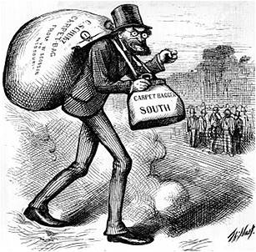

**A. Charles Schurz, who was a Northern Republican, is shown in a positive light as he heads to the South in enact Reconstruction policies.**

**B. The southern citizens in the background are cheering his arrival due to the cooperation taking place between northern and southern politicians.**

**C. The southern citizens in the background are actively attempting to prevent the arrival of the carpetbaggers they feared and hated with a passion.**

**D. Charles Schurz is shown in a negative light since he is depicted as a grim and intense intruder with clenched fists.**

3. We have been taught to hunt and live on the game. You tell us that we must learn to farm, live in one house, and take on your ways. Suppose the people living beyond the great sea should come and tell you that you must stop farming, and kill your cattle and take your houses and lands, what would you do? Would you not fight them?”

--Gall, a Hunkpapa Sioux Indian, quoted in Bury My Heart at Wounded Knee

What was Gall’s view of future relations between the Plains Indians and the settlers?

**A.            Peaceful coexistence**

**B.            Further conflict**

**C.            Mutual respect**

**D.            Equality**

4. The table below provides information about the African-American population in several cities after the Civil War.

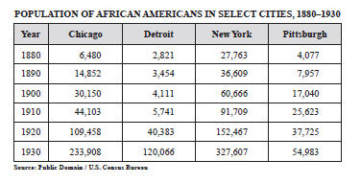

Which condition in society was primarily responsible for the change in urban population?  
**A. absence of agricultural employment in Southern communities**  
**B. lack of political representation in Southern communities**  
**C. availability of job opportunities in Northern cities**  
**D. prevalence of racial equality in Northern cities**

5. The most direct effect of poll taxes and literacy tests on African Americans was to:  
**a.  prevent them from voting**  
**b.  limit their access to public facilities**  
**c.  block their educational opportunities**  
**d.  deny them economic advancements**

**6.** In the 1850s, the phrase “Bleeding Kansas” was used to describe clashes between  
**a. proslavery and antislavery groups**  
**b. Spanish landowners and new American settler**  
**c. Chinese and Irish railroad workers**  
**d. Native American Indians and white settlers**

7. The Homestead Act, the mass killing of buffalo, and the completion of the transcontinental railroad are most closely associated with the  
**a. rise of organized labor**  
**b. building of the Erie Canal**  
**c. northern migration of African Americans**  
**d. decline of the Plains Indians**

**8.** Many Southern States tried to limit the effects of Radical Reconstruction by  
**a. adopting federal laws mandating segregation**  
**b. enacting Jim Crow laws**  
**c. abolishing the Southern sharecropping system**  
**d. securing passage of new amendments to the United States Constitution**

9. On March 3, 1845, Florida joined the Union as a slave state, while Iowa became a free state. This entrance into the Union as a pair was required under what document?

**A. Missouri Compromise**

**B. Compromise of 1850**

**C. Adams-Onis Treaty**

**D. Fillmore Agreement**

10. The following excerpt is from the Thirteenth Amendment which was passed by the U.S. Congress on December 6, 1865. After reading it, chose which statement best summarizes the Amendment.

**"Neither slavery nor involuntary servitude, except as a punishment for crime whereof the party shall have been duly convicted, shall exist within the United States, or any place subject to their jurisdiction."**

**A. The Thirteenth Amendment freed all slaves and therefore allowed them the same rights as all other citizens of the United States.**

**B. The Thirteenth Amendment freed all slaves which now allowed therefore allowed any type of discrimination.**

**C. The Thirteenth Amendment outlawed slavery but did not specify an African-American’s political rights.**

**D. The Thirteenth Amendment brought about an end to the Civil War since it outlawed slavery.**

11. Which of the following statements is true concerning the map pictured below?

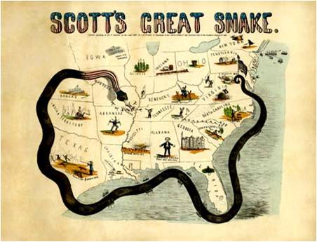

**A. The Union thought that by blockading the southern ports they could easily win the war.**

**B. The Union wanted to shut the south off from all possible help in an attempt to squeeze the Confederacy into submission.**

**C. The snake’s head begins in the Union’s capital and tail ends in the Confederate capital to mark the journey the soldiers would face during the war.**

**D. The Union knew that the Confederacy had the industrial advantage so they were attempting to cut off any exportation of goods.**

12. The common purpose of these legislative acts were to

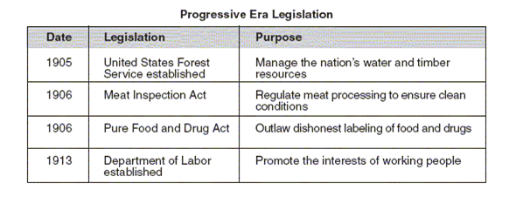

**A. protect the nation’s natural resources**

**B. improve conditions for recent immigrants to the United**

**C. advance the growth of big business**

**D. promote the general welfare of the American public**

13. Until the early 20th century, few restrictions on immigration to the United States existed primarily because

**A.  industry needed an increasing supply of labor**

**B.  immigration totals had always been relatively low**

**C.  labor unions had always favored unrestricted immigration**

**D.  the Supreme Court had ruled that Congress could not restrict immigration**

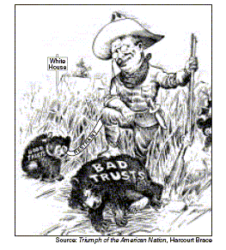14.

The cartoon illustrates President Theodore Roosevelt’s attempt to

A.    ignore antitrust laws

B.    conserve natural resources

C.    limit the power of monopolies

D.    eliminate foreign ownership of United States corporations

15. In the late 1800s, how did railroad monopolies create economic hardships for farmers?

A.      By claiming productive land for business leaders to develop

B.      By charging high prices to ship agricultural goods to market

C.      By separating farmers from profitable markets in western cities

D.      By isolating farmers from technological developments in eastern cities

16. In 1862, the Homestead Act and the Pacific Railway Act were passed primarily to  
**a.  achieve Northern victory in the Civil War**  
**b.  develop the Midwest and western parts of the country**  
**c.  improve the lives of freed slaves**  
**d.  expand overseas markets to Asia and Europe**

17. The political cartoon pictured below is titled "Modern Colossus of (Rail) Roads," and was drawn in 1879. It depicts Cornelius "the Commodore" Vanderbilt and the sign reads "all freight leaving the seaboard MUST pass here and pay any tolls we demand”. Use the 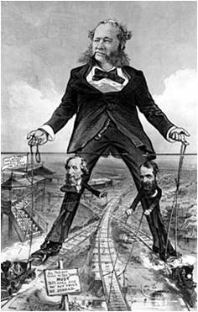cartoon and your knowledge of U.S. history to answer the question below.

The reins held by Vanderbilt attach not only to the trains but also to the tracks and the railroad station. What does this convey about his control of the Railroads?

a. Vanderbilt has total control of the entire railroad operation. Thus, he can do with it whatever he wants.

b. Vanderbilt, along with two assistants, has the majority of control in railroad shipping operations.

c. Vanderbilt controls the prices of railroad shipping, but has little involvement in the action operations.

d. Vanderbilt owns the majority of the railroads, but has little involvement of any kind.

18. Which technologies helped settlers establish farms on the Great Plains?

             A. repeating rifle, wooden sluices, electric light bulb

            B. sod houses, sheep shearers, wool carders

            C. telegraph, railroad, creation of Yellowstone National Park

            D. steel plow, windmill, barbed wire, reaper

19. The political cartoon below, drawn in 1904, depicts Theodore Roosevelt and lions each marked with the name of a business trust. Use your knowledge of U.S. history to answer the following question.

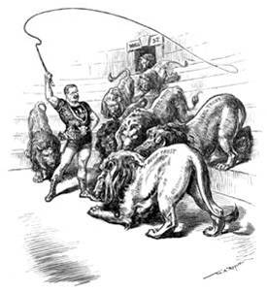

What do you think is the cartoonists’ view on trust-busting in the early 20th century?

A. Businesses who involve themselves in trusts are weak and therefore pose no danger to the U.S. economy.

B. The government plays only a small role in eliminating trusts that have formed within the United States.

C. Roosevelt wants to only curb trusts’ power within the economy, rather than eliminate them altogether.

D. Roosevelt is admired for his powerful stance on destroying trusts within the United States.

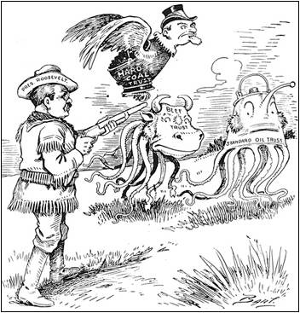

20. In the cartoon above, President Theodore Roosevelt is depicted doing which of the following?

A.  Standing guard to protect big business

B.  Enforcing the Sherman Anti-Trust Act

C.  Leading a government take-over of large industries

D.  Putting an end to industries that might harm the environment

21.

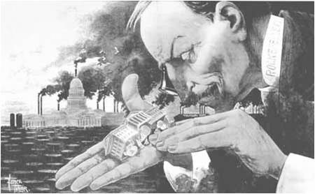

Based on your knowledge of the Second Industrial Revolution in the United States, what statement is this cartoon making?

A. The federal government is ruining the oil industry by placing too many restrictions and regulations on business owners.

B. The oil industry is thriving due to a healthy working relationship with the federal government.

C. The owner of Standard Oil has too much power and influence over the federal government.

D. Emissions from oil refineries are polluting the air and harming the environment.

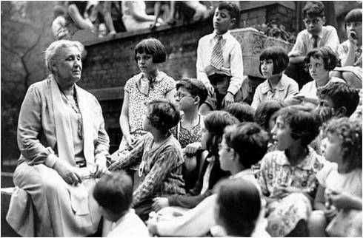

22. The picture above shows Jane Adams with some of the children being served by Hull House in Chicago, Illinois.  What goal of the Progressive Era is represented by this image and the existence of Hull House?

A. Fostering efficiency

B. Protecting social welfare

C. Creating economic reform

D. Promoting moral improvement

23.“[Where trade unions are most firmly organized, there are the rights of the people most respected.](http://www.brainyquote.com/quotes/quotes/s/samuelgomp205279.html)”

Based on your knowledge of the labor movement in the late 19th and early 20th century, to whom would this quote be attributed?

**A. Theodore Roosevelt**

**B. John Rockefeller**

**C. Samuel Gompers**

**D. Andrew Carnegie**

## **24.**

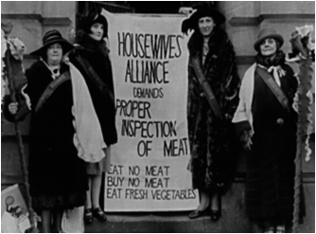

Based on your knowledge of written works in the late 19th and early 20th centuries, which of the following most likely inspired the demand being made by the women pictured above?

A. *The Great American Fraud* by Samuel Hopkins Adams

B. *The Shame of Cities* by Lincoln Steffens

C. *The Jungle* by Upton Sinclair

D. *How the Other Half Lives*  by Jacob Riis

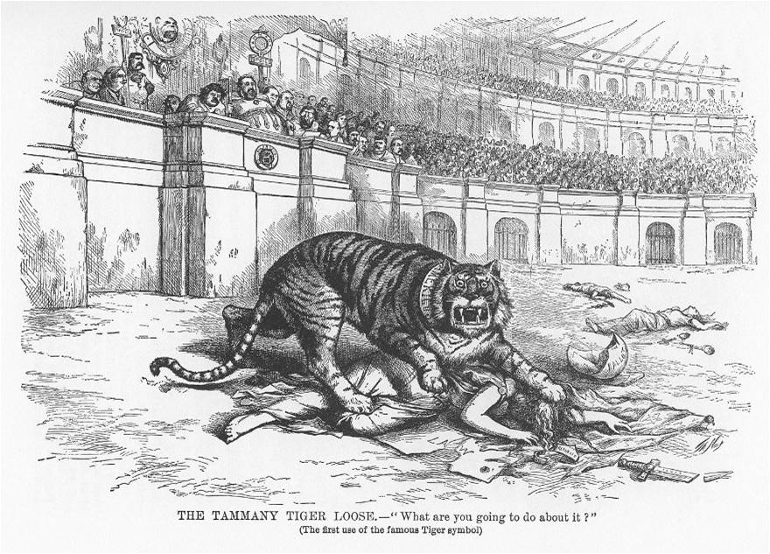

25.

Cartoonists Thomas Nast chose the tiger as a symbol to represent which of the following?

A. The unlimited power of the robber barons

B. The impact of trust-busting on business in the US

C. The influx of immigrants and their impact on the US

D. The corrupt local government of New York City

26.

“The American Beauty Rose can be produced in the splendor and fragrance which bring cheer to its beholder only by sacrificing the early buds which grow up around it. This is not an evil tendency in business. It is merely the working-out of a law of nature and a law of God. “

**–John Rockefeller**

Which of the following conclusions could be drawn about John Rockefeller based on the quote above?

**A. He was a strong supporter of government regulation in business.**

**B. He was a proponent of trust-busting and opposed any one company having too much control over an industry.**

**C. He welcomed competitors because he knew competition was beneficial to consumers.**

**D. He supported the theory of Social Darwinism.**

27. During the early 1800s, which factor contributed the most to the start of the Industrial Revolution in the United States?

**A. a restriction on European immigration**

**B. the end of the slave labor system**

**C. an abundance of natural resources**

**D.  the availability of electricity**

**28.** What was an immediate effect of the completion of the Erie Canal in 1825?

**A.  Prices increased for food products along the Atlantic Coast.**

**B.  Farmers could more easily ship grain to eastern markets.**

**C. A territorial conflict began with Canada over the Great Lakes.**

**D. Railroads were forced to reduce their shipping rates.**

29. A major purpose of the Progressive movement (1900–1917) was to

**A. stimulate the economy**

**B. support government control of factory production**

**C. encourage immigration from southern and eastern Europe**

**D. correct the economic and social abuses of industrial society**

The cartoon below depicts a social issue in United States history.

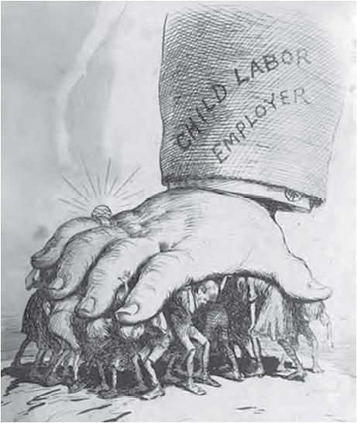

30. With which social issue is this cartoon associated?

A. the power of political machines during the Second Industrial Revolution

B. the power of big businesses during the Second Industrial Revolution

C. the influence of immigration quotas during the Gilded Age

D. the influence of suffrage reformers during the Gilded Age

31. Which of the following contributed to the immense industrial boom known as the Second Industrial Revolution?

A. bankruptcy of farms, populist movement, loss of farming lands

B. abundance of natural resources, government support of businesses, increase in urban population

C. cheap city buildings, women’s movements, great migration

D. new public education system, discovery of oil in Pennsylvania, formation of trusts

32. Which factor is most closely associated with the decision of the United States to declare war on Spain in 1898?  
a.  isolationist policy  
b.  labor union pressure  
c.  yellow journalism  
d,  unrestricted submarine warfare

33. The United States issued the Open Door policy (1899–1900) primarily to  
a. bring democratic government to the Chinese people  
b. secure equal trade opportunities in China  
c. force China to change its immigration policies  
d. use China as a stepping stone to trade with Japan

34. The diagram below provides details about United States involvement in China during the late 1800s and early 1900s.

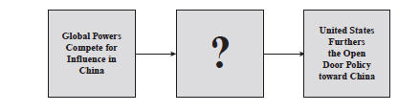

Which phrase completes the diagram?  
A. United States Develops Interest in Chinese Markets  
B. United States Makes Commitment to Free Elections  
C. United States Plans Establishment of Military Bases  
D. United States Supports Democracy in Chinese Communities

35. The political cartoon below depicts William McKinley at the onset of the Spanish-American War. Use your knowledge of U.S. history to choose the statement below that most accurately summarizes the drawing.

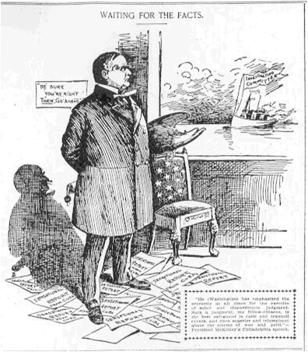

A. McKinley looked for any provocation from Spain since he eagerly wanted to go to war so that the U.S. could secure new territories such as Cuba.

B. McKinley wanted to secure new territories, but took cautious steps before proceeding to war with Spain.

C. McKinley cared little for new territories; rather his major concern was furthering the labor union movements within the U.S.

D. Imperialism played only a minor role in U.S. policies during the late 19th century.

36. Use the map and your knowledge of U.S. history to answer the question below.

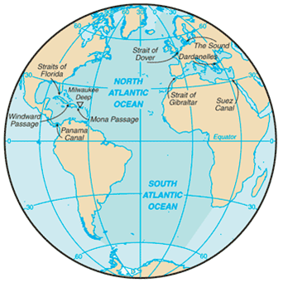

Which of the following best explains why the building of the Panama Canal supported United States’ efforts to become a world power?

A. It gave the U.S. a colony in Central America

B. It prevented Japan and China from attacking Hawaii.

C. It opened up a new avenue for trade with China.

D. By providing a shortcut between the Atlantic and Pacific Oceans, it opened up new trading opportunities.

37. Which of the following was NOT a factor in U.S. imperialism?

A. the desire for increased military strength

B. the desire for new markets overseas

C. competition with Japan for control of China

D. the belief that the U.S. had a duty to spread Christianity and civilization

38. In 1898 the relatively moderate sized town of Tampa Bay, Florida, acquired the title of “on the map”. Which of the following events lead to this once sleepy-little town becoming an area of vast importance?

A. Sight of U.S.S. Maine explosion and cause for declaration of war between the U.S. and Spain

B. Military port for soldiers and supply point for food, ammunition, and medical supplies that were destined for Cuba

C. Base used Cuban revolutionaries to secure shipments of uniforms and ammunition in their fight for independence

D. Port of cultivation for numerous battleships used throughout Spanish-American War

39. A major purpose of President Woodrow Wilson’s Fourteen Points (1918) was to  
a. ask Congress to enter World War I  
b.  set goals for achieving peace after World War I  
c.  provide an aid program for rebuilding war-torn nations  
d.  retaliate for the sinking of the Lusitania

Base your answers to 40 and 41 on the passage below:

*We intend to begin on the first of February unrestricted submarine warfare. We shall endeavor in spite of this to keep the United States of America neutral. In the event of this not succeeding, we make Mexico a proposal of alliance on the following basis: make war together, make peace together, generous financial support and an understanding on our part that Mexico is to reconquer the lost territory in Texas, New Mexico, and Arizona. The settlement in detail is left to you.…*  
— Telegram of January 19, 1917

40. This telegram was part of an effort to  
a. form an alliance between Germany and the United States  
b. convince several western states to secede from the United States  
c. bring Mexico into World War I on the side of Great Britain and France  
d. enlist Mexican support for Germany if the United States declared war

41. Publication of this telegram in United States newspapers helped to  
a. reelect Woodrow Wilson as president  
b. convince the American public to support entrance into World War I  
c. encourage Congress to pass neutrality legislation  
d. grant statehood to Arizona and New Mexico

42. Henry Cabot Lodge and other senators opposed ratification of the Treaty of Versailles (1919) because they believed the treaty  
a. failed to punish Germany for its involvement in World War I  
b. excluded reparations for European allies  
c. could draw the United States into future conflicts  
d.  placed blame for World War I on all the warring countries

43. The United States tried to avoid involvement in World War I by following a policy of  
a. neutrality  
b. collective security  
c. economic boycotts  
d. military preparedness

44. The main reason for the increased migration of African Americans out of the rural South during and following World War I was the  
a.  availability of cheap farmland in the West  
b. opportunity for factory jobs in the North  
c. chance to escape racial segregation by joining the military  
d. elimination of the Ku Klux Klan in the northern states

45. The newspaper headline below describes a significant event in U.S. foreign affairs.  
DAILY NEWS  
– MAY 7, 1915 –  
LUSITANIA SUNK: OVER ONE HUNDRED AMERICANS LOST AT SEA  
How did this event contribute to the United States’ entry into World War I?  
A. It furthered anti-government protests in the United States.  
B. It encouraged anti-immigration campaigns in the United States.  
C. It became necessary for President Wilson to propose a plan for peace.  
D. It became difficult for President Wilson to defend a policy of neutrality.

46. Use the pie chart below and your knowledge of U.S. history to answer the following question.

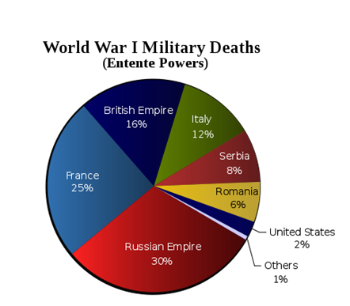

Which of the following reasons best accounts for the percentage of U.S. deaths in relation to other countries’ percentage.

A. The U.S. entered the war early and therefore experienced a great number of deaths on the battlefield.

B. The U.S. experienced a large number of accidental deaths which contributed to a high percentage of deaths.

C. The U.S. entered the war late and therefore experienced a low number of deaths on the battlefield.

D. The U.S. had a large number of men volunteer to fight alongside Russia, which meant that they were counted as part of Russia’s percentage of deaths.

47. Which of the following was NOT a cause of World War I?

            A. nationalism

            B. imperialism

            C. militarism

            D. socialism

48. In 1914 which of the following Florida locations was chosen by the United States Navy as the sight of the first permanent naval air station because the climate allowed for year-round flying?

            A. St. Augustine

            B. Key West

            C. Tampa Bay

            D. Pensacola

49. In the 1920s, which United States action furthered the goal of international peace?

A.      Signing a pact to outlaw armed conflict

B.      Advocating a policy to promote isolationism

C.      Holding a conference to renounce imperialism

D.      Joining a league to secure military cooperation

50. One goal for a lasting peace that President Woodrow Wilson included in his Fourteen Points was

A. establishing a League of Nations

B. maintaining a permanent military force in Europe

C. returning the United States to a policy of isolationism

D. blaming Germany for causing World War I